Sixteen Days of Activism!
Welcome to Zonta Club of Corvallis’ Day 7 of “Sixteen Days of Activism” for 2023.
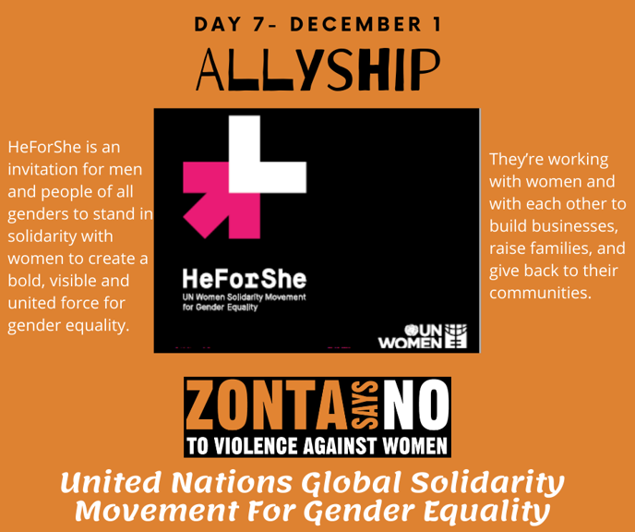
Click here to learn more about HeForShe!
Michael Kimmel is one of the world’s leading experts on men and masculinity. He is a SUNY Distinguished Professor at Stony Brook University. A tireless advocate of engaging men to support gender Equity, Kimmel has lectured at more than 300 colleges, universities, and high schools. Check out this inspiring TED Talk given by Dr. Kimmell, Why Gender Equity is Good for Everyone - Men Included!Learn more and get involved with #Zontasaysno to violence against women and supporting gender equity at ZontaSaysno.com.

