Sixteen Days of Activism!
Welcome to Zonta Club of Corvallis’ Day 15 of “Sixteen Days of Activism” for 2023.
Service to support the Ukrainian Zonta Clubs have been what many Zontians world-wide have been about since the inception of the war. Check out this Zoom presentation “Ukraine Building Back Better” hosted by the Zonta Club of Brooklyn New York to learn how many different Zontians are involved in supporting Ukraine! If you would like to support the Ukrainian clubs their efforts with a donation, please follow this link!
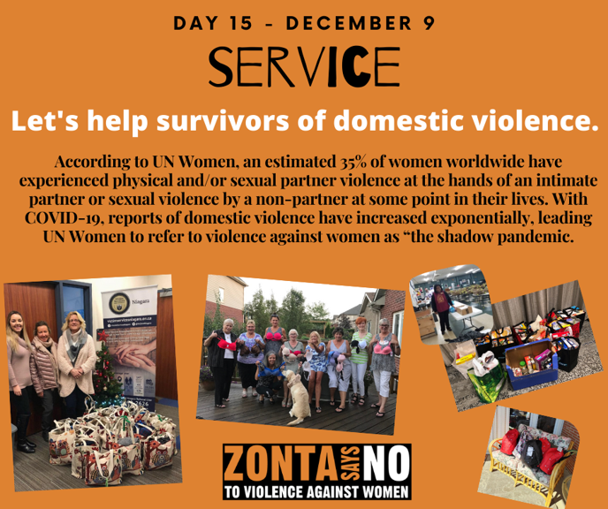
Learn more and get involved with #Zontasaysno to violence against women and supporting gender equity at ZontaSaysno.com

