Sixteen Days of Activism!
Welcome to Zonta Club of Corvallis’ Day 8 of “Sixteen Days of Activism” for 2023.
Individual advocacy is an important part of securing Equity for women and girls. The Zonta USA Caucus is a great source of advocacy opportunities on important issues facing the U.S. Congress including Ending Child Marriage, Ratifying the ERA, Eliminating Gender Violence, Women’s Health, Climate Change and Women in the Workplace. Fast Action Friday is a unique tool that affords individuals the opportunity to send a personalized email on pending legislation to their Congressional Delegation in a matter of minutes. To learn just how easy this form of advocacy is to use check out this brief video on Fast Action Fridays. After viewing the video sign up here to receive Fast Action Friday alerts!

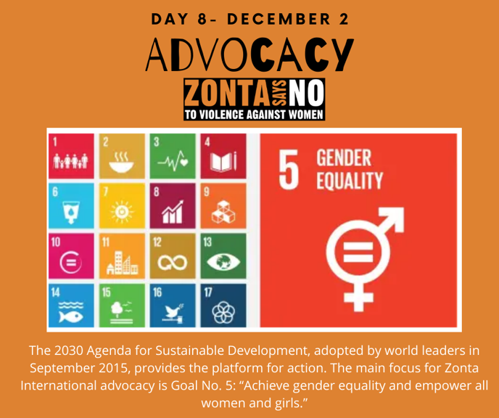
Learn more and get involved with #Zontasaysno to violence against women and supporting gender equity at ZontaSaysno.com

