Sixteen Days of Activism!
Welcome to Zonta Club of Corvallis’ Day 11 of “Sixteen Days of Activism” for 2023.
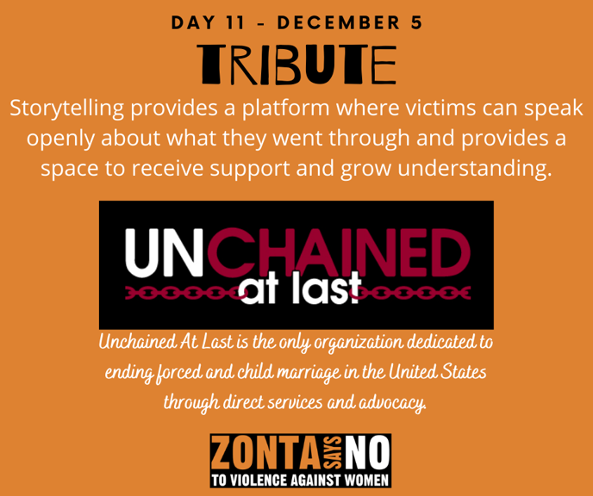
To learn more about Unchained at Last check out their website! Ending Child marriage is a key advocacy area for Zonta International. Check out the website and PSA’s, Zonta International and UNICEF USA have created to end child marriage!
Tomorrow at our monthly business and program meeting we will be encouraging all members to participate in our club’s “Orange Out” by wearing orange to our meeting to bring attention to Zonta Says No! Look for photos from the meeting to be on our Facebook page soon!

Learn more and get involved with #Zontasaysno to violence against women and supporting gender equity at ZontaSaysno.com

