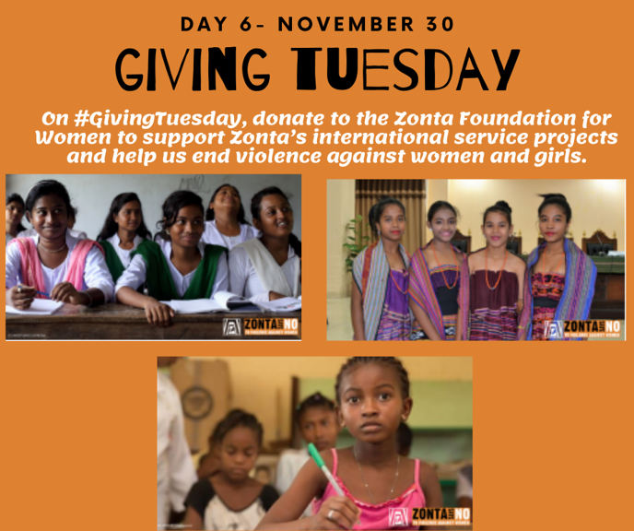
- The donation page for the Zonta International Foundation can be found here!
- If you prefer to donate to Zonta Service Foundation of Corvallis and help support women locally you can do so here.
- If you are interested in supporting the three Ukrainian Club who are supporting the many women in need during the this time of war with Russia you can donate here.

Learn more and get involved with #Zontasaysno to violence against women and supporting gender Equity at ZontaSaysno.com

