Sixteen Days of Activism!
Welcome to Zonta Club of Corvallis’ Day One of “Sixteen Days of Activism” for 2023.
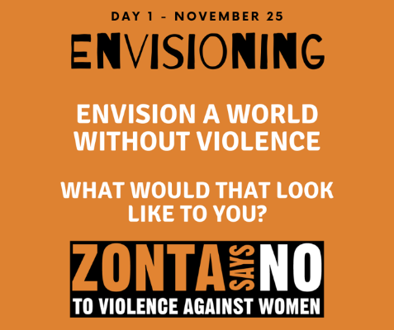
Welcome to Zonta Club of Corvallis’ Day One of “Sixteen Days of Activism” for 2023.
Light Up the Bridge . . . . Join Zonta Club members from Oregon and Washington who will be convening in Portland near the Morrison Bridge early on Saturday, November 25 at 4:30 when the bridge is bathed in orange lights in support of “Zonta Says No to Gender Violence”. Zonta District Eight Governor, Deb Lal will be in attendance as we demonstrate our support and remembrance of domestic violence victims.
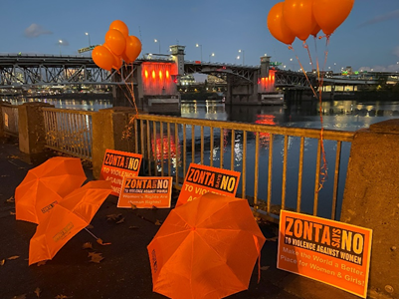
Learn more and get involved with #Zontasaysno to violence against women and supporting gender equity at ZontaSaysno.com

