Sixteen Days of Activism!
Welcome to Zonta Club of Corvallis’ Day Four of “Sixteen Days of Activism” for 2023.
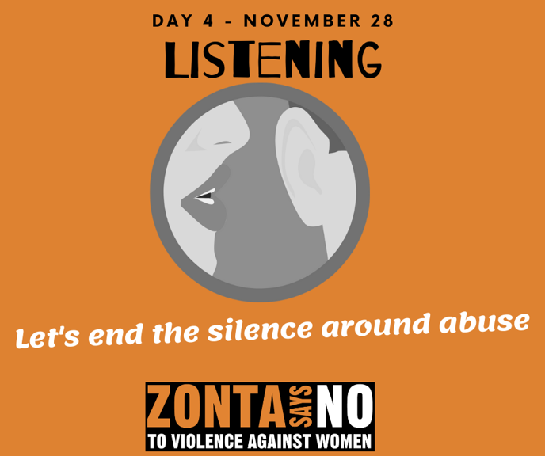
Listen to survivors of domestic violence tell their story on this CBS News Report!
Learn more and get involved with #Zontasaysno to violence against women and supporting gender equity at ZontaSaysno.com

