Sixteen Days of Activism!
Welcome to Zonta Club of Corvallis’ Day Five of “Sixteen Days of Activism” for 2023.
Learn what the community of Stockton, California did to commemorate deceased victims of domestic violence in this compelling news story!
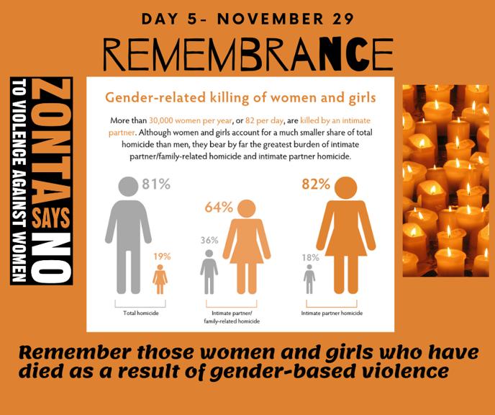

Learn more and get involved with #Zontasaysno to violence against women and supporting gender equity at ZontaSaysno.com

