Sixteen Days of Activism!
Welcome to Zonta Club of Corvallis’ Day Three of “Sixteen Days of Activism” for 2023.
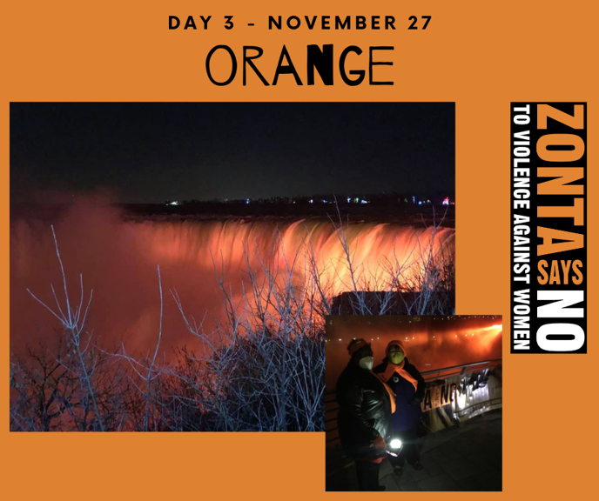
Learn what other clubs around the world are doing to support #Zontasaysno!

Learn more and get involved with #Zontasaysno to violence against women and supporting gender equity at ZontaSaysno.com

