Sixteen Days of Activism!
Welcome to Zonta Club of Corvallis’ Day 14 of “Sixteen Days of Activism” for 2023.
Day 14 – December 8
Community

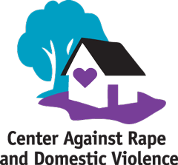
Check out CARDV one of our local organizations who has been supporting survivors of domestic violence since the early 1960’s. Corvallis Zonta has been a long-time supporter of this critical Corvallis organization!
Learn more and get involved with #Zontasaysno to violence against women and supporting gender equity at ZontaSaysno.com

