Sixteen Days of Activism!
Welcome to Zonta Club of Corvallis’ Day 10 of “Sixteen Days of Activism” for 2023.
A relatively new advocacy area of concern for Zonta is the unequal impact of Climate Change on women and girls. Please see the video on the nexus between Climate Change and Violence Against Women. It was created by Carole Theobald, Chair of “Zonta Says NOW” Working Group on Climate Change.
Zonta International has developed a substantial campaign including a policy statement regarding Climate Change and why it is a critical area of advocacy. The Zonta USA Caucus is very active in this advocacy area, check out their Climate Change page.
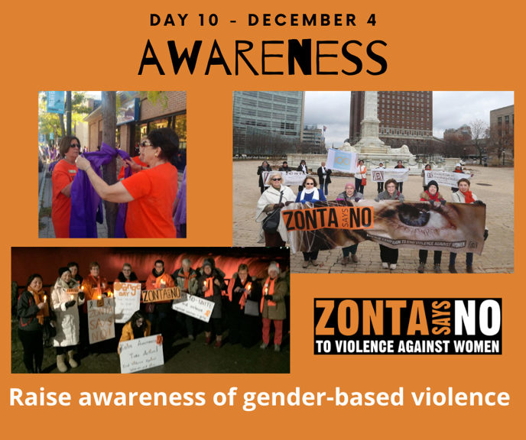
Learn more and get involved with #Zontasaysno to violence against women and supporting gender equity at ZontaSaysno.com

