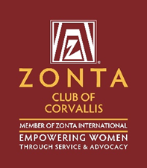

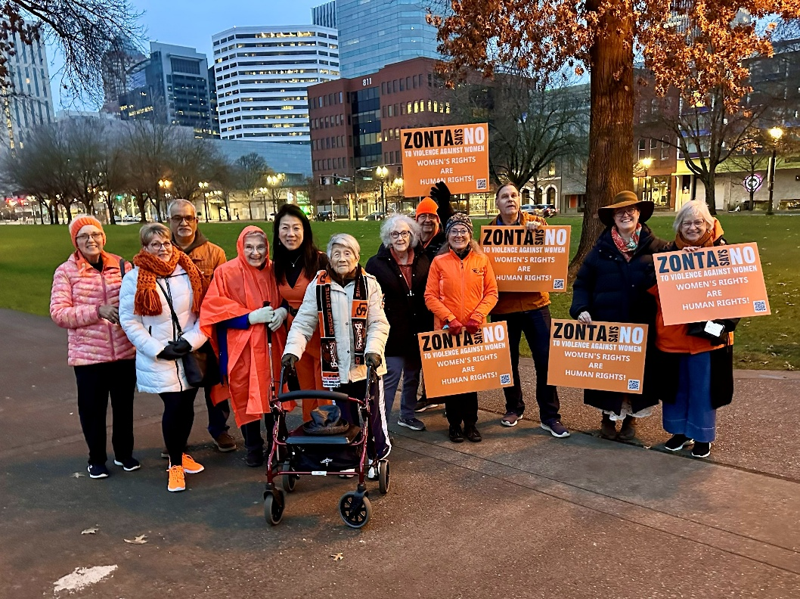
The Zonta Club of Corvallis Presents 16 Days of Activism!
Welcome to the Zonta Club of Corvallis’ “Sixteen Days of Activism” campaign for 2025. The world-wide campaign will be championed by Zonta Clubs and other organizations from November 25, The International Day of Remembrance for all women and girl victims of violence to December 10, the International Day of Human Rights.
Starting on November 25 we will feature sixteen days of information and examples of actions individuals can take to advocate on behalf of women and girls. Look on our Facebook, Instagram or web site for new information or action items each day during the campaign.

ZontaSaysno.com

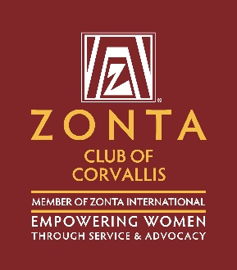
Sixteen Days of Activism!
Welcome to Day One of the Zonta Club of Corvallis’ “Sixteen Days of Activism”
International Day for the Elimination of Violence Against Women Tuesday, November 25

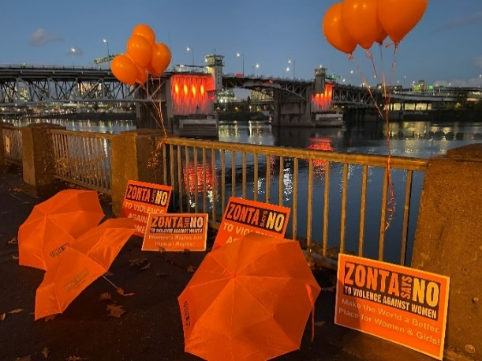
Light Up the Bridge . . . .we had a fantastic pre-campaign event Saturday November 22 when we lit up the Morrison Bridge in Portland. The bridge was bathed in ORANGE in support of “Zonta Says No To Violence Against Women!”.
Zonta District 8 joined others around the world in lighting international landmarks in ORANGE including Niagara Falls, the Eiffel Tower, and the Sydney Opera House to recognize the victims who have died as a result of gender-based violence.

ZontaSaysno.com

Welcome to Day Two of the Zonta Club of Corvallis’ “Sixteen Days of Activism”
International Day for the Elimination of Violence Against Women Tuesday, November 25.

The upcoming Thanksgiving holiday is a special time of the year with the gathering of families, bountiful tables of special holiday foods and an opportunity to offer thanks and acknowledgement of the importance of family and friends. However, for many survivors the holiday season can be a very stressful time.
You can learn more about the potential impacts and challenges of the holiday season on survivors from The National Network to End Domestic Violence (NNEDV)

ZontaSaysno.com
Sixteen Days of Activism!
Welcome to Zonta Club of Corvallis’ Day Three of “Sixteen Days of Activism” for 2025.


ZontaSaysno.com

Sixteen Days of Activism!
Welcome to Zonta Club of Corvallis’ Day Four of “Sixteen Days of Activism” for 2025
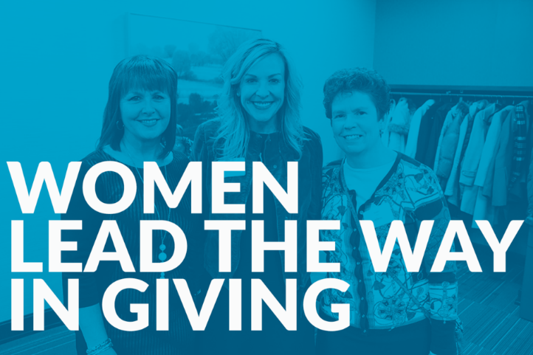
There are many ways to “Just Say No” - advocacy, activism, compassion, support services, safe housing, and direct volunteerism are ways to support survivors.
A critical and important support is charitable giving! In these times of substantial reductions in Federal funding private giving is critical to insure important programs and services for women and girls continue to exist! There are a vast number of international organizations such as the Zonta Foundation for Women Whose work would not be possible charitable donation. The Zonta Club of Corvallis gives to many local organizations who empower women, amplify their voices, support survivors, and/or work to prevent gender violence. In addition as well as multiple scholarships to women attending Linn-Benton Community College and Oregon State University. When you give to the ZONTA SERVICE FOUNDATION OF CORVALLIS you are donating to many great organizations in our community whose works supports the mission of Zonta. Check out the following link to learn more about our scholarship programs and see the organizations we supported.
ZontaSaysno.com
Sixteen Days of Activism!
Welcome to Zonta Club of Corvallis’ Day 5 of “Sixteen Days of Activism” for 2025.
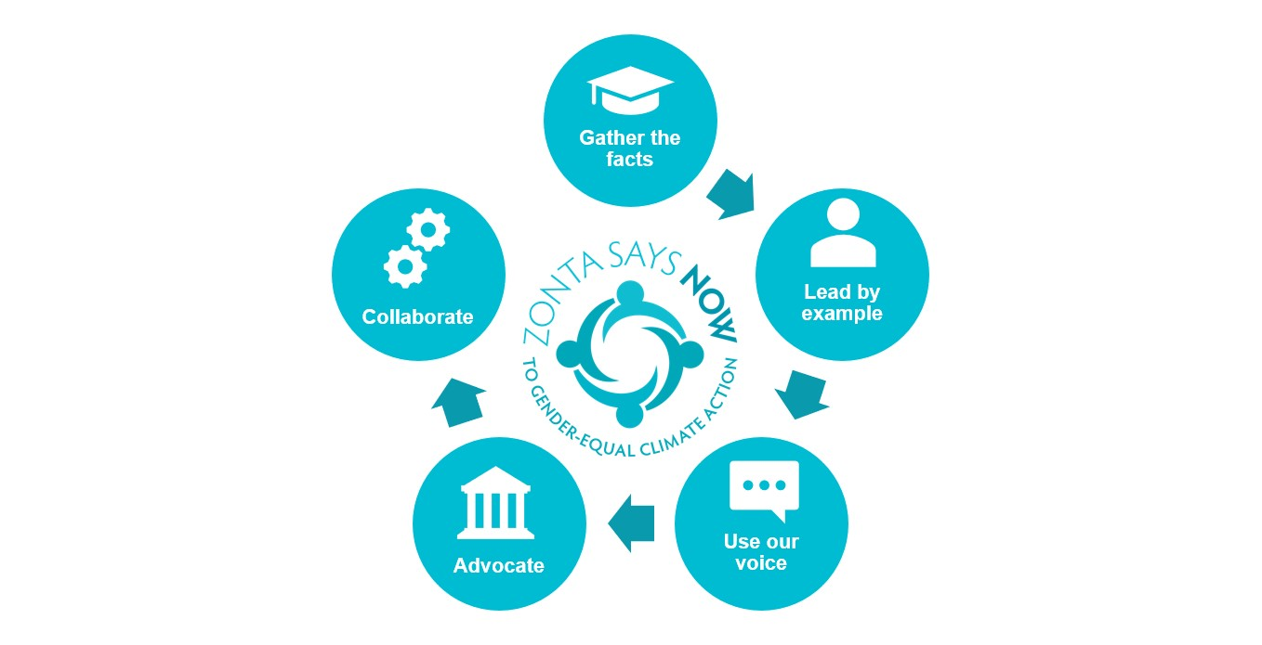
Zonta International has developed a substantial campaign including an extensive policy statement regarding Climate Change and gender equity climate action. Leading this effort is the Just Say Now Committee, who have created a comprehensive, multi-strategic approach to encourage awareness, education and action in this critical area of advocacy. Here is a three minute video that explains the connection between climate change and the disproportionate impact on women and girls.
Zonta International has created a unique awareness effort entitled Envisioning a Gender-Equal Sustainable Future Through The Arts. Check it out and see the many expressive ways Zontians and others are sharing their thoughts on this important topic.
Zonta District 8 has a meeting designed to educate and create awareness about Climate Change each odd-numbered month of the year. Zonta members and non-members are invited to learn about and discuss the many facets of climate change. To learn about upcoming meetings check out the Zonta D-8 Event Calendar.

ZontaSaysno.com
Sixteen Days of Activism!
Welcome to Zonta Club of Corvallis’ Day 6 of “Sixteen Days of Activism” for 2025.
Gain Empathy and Understanding of Survivors’ Experience through Literature
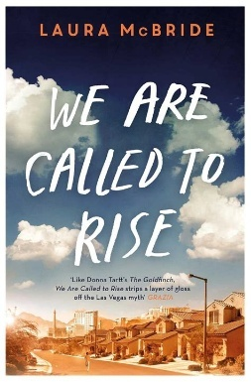
Every year during the 16 Days of Activism, Zontians join voices with others around the world to say Just Say No to Violence and Inequality. On this day we invite you to witness and learn through literature how women confront fear, loss, and injustice-and how they rise to reclaim their stories. This selection of books curated by Victoria Condor-Williams, Corvallis Zonta Advocacy Committee Member provides a selection of powerful books which promote awareness and understanding about domestic violence through the power of storytelling.
Across continents and generations, these novels reveal the many faces of violence−from the intimate and unseen to the political and systemic−and the resilience that emerges when women stand together. Through Allende’s intergenerational saga, Nam−Joo’s piercing social realism, Temelkuran’s powerful exploration of freedom, and McBride’s deeply human narrative of empathy and repair, we are reminded that storytelling is itself an act of resistance and healing.
Theses voices call us not only to reflect, but to act−to imagine a world where every woman and girl lives free from violence and fear and where equality is not a dream, but a shared responsibility.
ZontaSaysno.com
Sixteen Days of Activism!
Welcome to Zonta Club of Corvallis’ Day 7 of “Sixteen Days of Activism” for 2025.
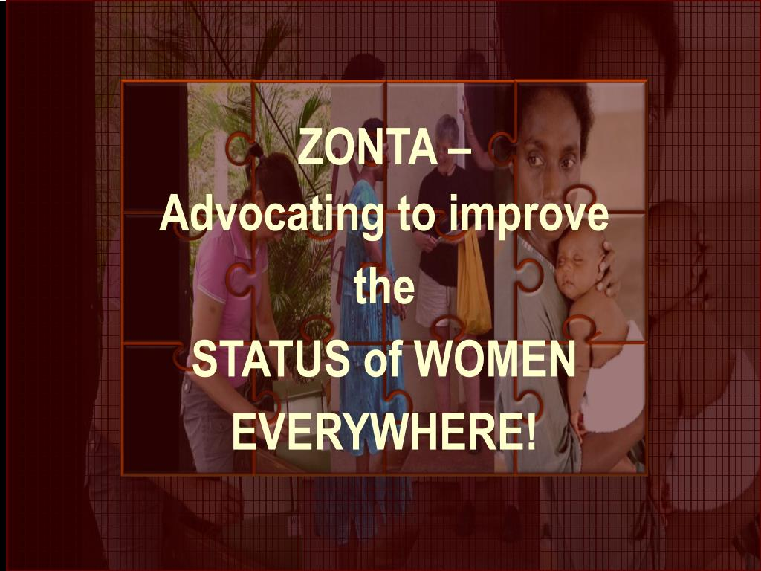

- Fast Action Friday is a unique tool that affords individuals the opportunity to send a personalized email on pending legislation to their Congressional Delegation in a matter of minutes. To learn just how easy this form of advocacy is to use check out this brief video on Fast Action Fridays. After viewing the video sign up here to receive Fast Action Friday alerts!

- An important part of advocacy is acknowledging the effective work of elected officials who create specific legislation which makes the world a better place for women and girls. One such elected official is State Senator, Sara Gelser Blouin who was extremely involved in the support and passage of successful legislation to End Child Marriage in Oregon. Why not send a card to the Senator thanking her for her support at 900 Court St. NE, S-211, Salem, Oregon 97301 or an email at Sen.SaraGelser@oregonlegislature.gov

ZontaSaysno.com
Sixteen Days of Activism!
Welcome to Day Eight of the Zonta Club of Corvallis’ “Sixteen Days of Activism”
Come join us for an “Orange Walk” following our regular business meeting today (Dec 2) at 1:00 at the Corvallis Community Center. We will walk from the Community Center to Harrison via 25th Street and then proceed to 27th Street returning to the Community Center carrying signs promoting Zonta’s message of “Make the world a better place for women and girls!”
Don’t forget to wear your orange!
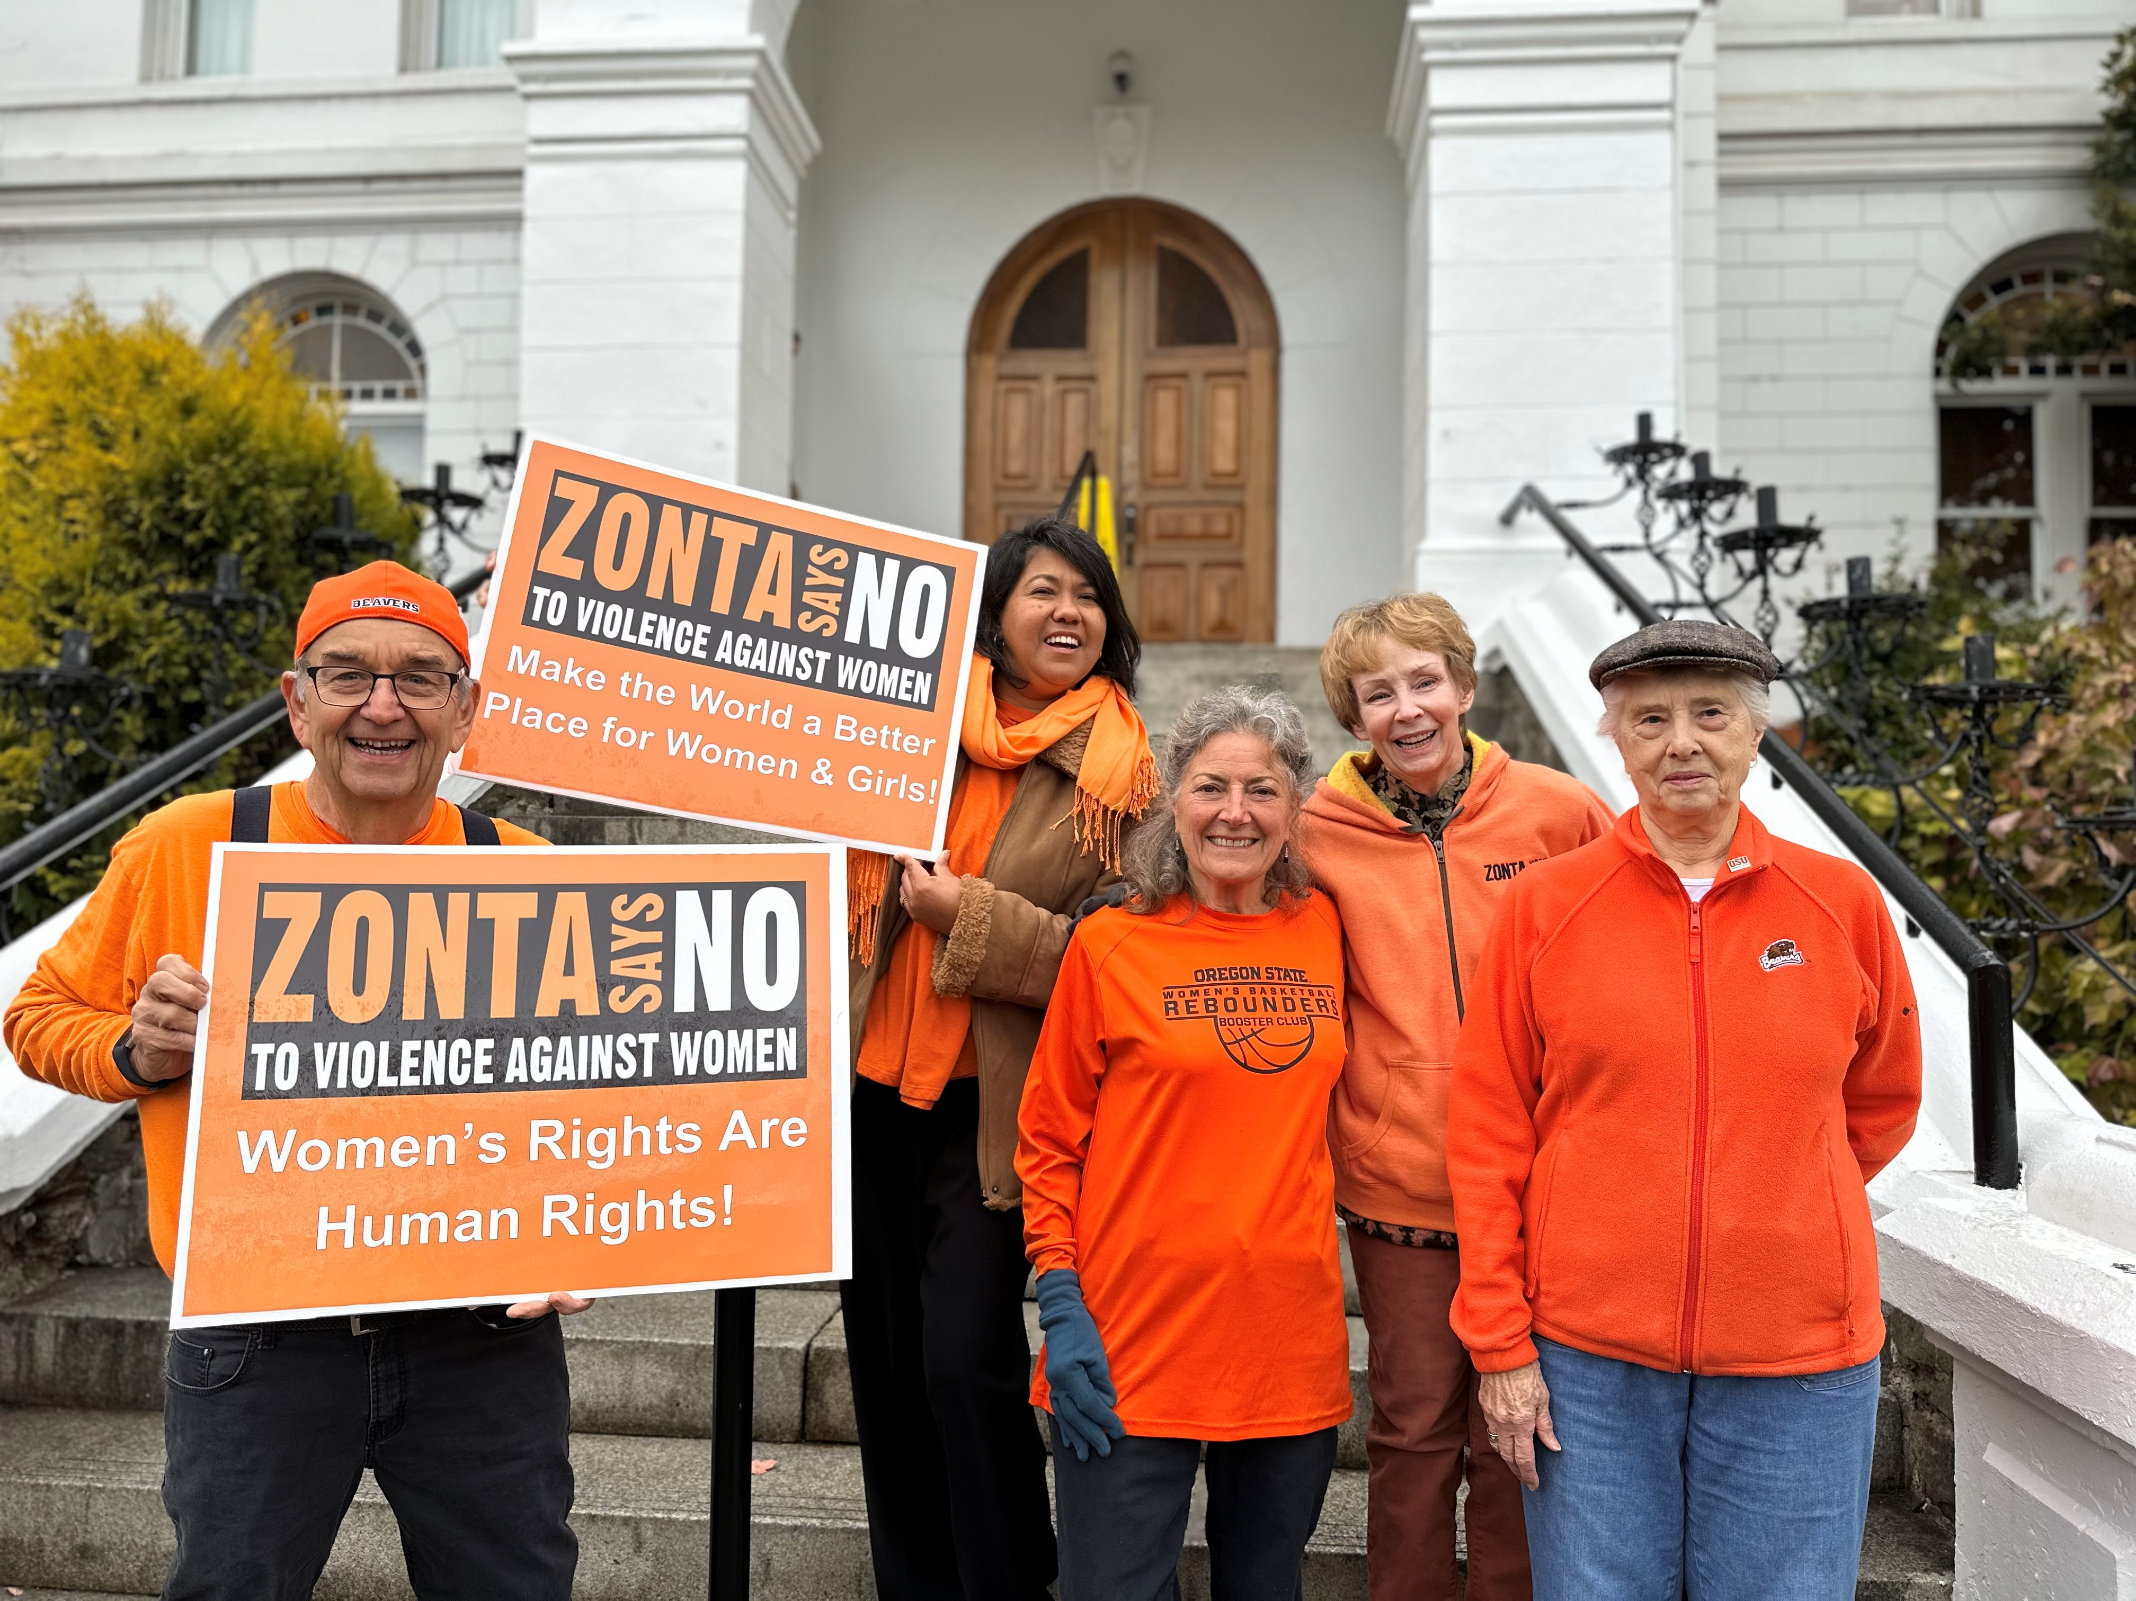


ZontaSaysno.com
Sixteen Days of Activism!
Welcome to Zonta Club of Corvallis’ Day Nine of “Sixteen Days of Activism” for 2025.
What a great turn out we had yesterday for our “Orange Walk”

ZontaSaysno.com
Sixteen Days of Activism!
Welcome to Zonta Club of Corvallis’ Day Ten of “Sixteen Days of Activism” for 2025.
Did you know that Zonta International has affiliate status with the United Nations?
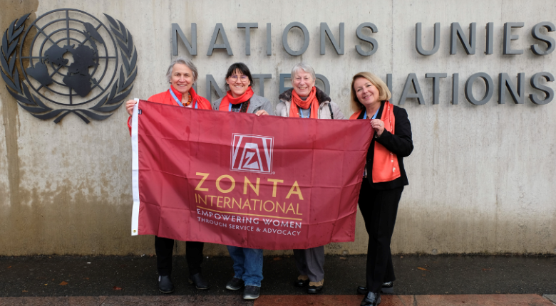
The Zonta International United Nations (UN) Committee teams represent Zonta in New York at the UN Headquarters, Geneva (Human Rights, ILO, WHO), Vienna (UNODC), Bangkok (ESCAP), Nairobi (UNEP), and Paris (UNESCO). The teams ensure that Zonta’s priorities are presented and that the Zonta voice is clear in mission-related meetings at their respective sites. They meet and work with decision-makers from UN agencies and countries where Zonta has funded projects and/or where Zonta clubs reside. Learn more about Zonta and the United Nations

ZontaSaysno.com

Sixteen Days of Activism!
Welcome to Zonta Club of Corvallis’ Day Eleven of “Sixteen Days of Activism” for 2025.
The Zonta USA Caucus; coordinating national and state legislative action!
Zonta USA Caucus is a great source of advocacy information on important issues facing the U.S. Congress and State Legislatures. Examples include Ending Child Marriage, Ratifying the ERA, Eliminating Gender Violence, Supporting Women’s Health, Climate Change Actions and Supporting Equality for Women in the Workplace.

ZONTA USA CAUCUS Mission:
- Encourage development, consideration, and passage of appropriate legislation by the US Congress, its members, and committees and by state legislatures.
- Take action in support of, or in opposition to, proposed or enacted legislation and executive orders and regulations that directly or indirectly impact the lives of women and girls.
- Promote women’s representation in decision-making positions on an equal basis with men.


ZontaSaysno.com

Sixteen Days of Activism!
Welcome to Zonta Club of Corvallis’ Day Twelve of “Sixteen Days of Activism” for 2025.
Children’s Book Selections on Domestic Violence for Zonta’s 16 Days of Activism

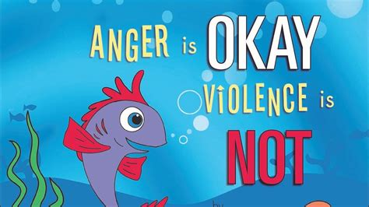
As part of Zonta’s 16 Days of Activism this selection of children’s books curated by Victoria Condor-Williams, Corvallis Zonta Advocacy Committee Member provides a selection of children’s books which promote awareness and understanding about domestic violence through the power of storytelling.
Children’s literature can be a gentle yet powerful tool to help young readers recognize emotions, understanding respect, and learn about safety and empathy. By introducing these stories early, we can nurture resilience, compassion, and kindness-planting the seeds to break the cycle of violence and inspire hope for safer communities.

ZontaSaysno.com
Sixteen Days of Activism!
Welcome to Zonta Club of Corvallis’ Day Thirteen of “Sixteen Days of Activism” for 2025.
Advocating for Women and Girls in a Digital World!

According to UN Women digital violence is intensifying, yet nearly half of the world’s women and girls lack legal protection from digital abuse. The UN Women’s 16 Days of Activism campaign demands a world where technology is a force for equality – not harm.
UN Women is calling for:
- Global cooperation to ensure digital platforms and AI tools meet safety and ethics standards.
- Support for survivors of digital violence by funding women’s rights organizations.
- Holding perpetrators accountable through better laws and enforcement.
- Tech companies to step up by hiring more women to create safer online spaces, removing harmful content quickly, and responding to reports of abuse.
- Investments in prevention and culture change through digital literacy and online safety training for women and girls, and programs that challenge toxic online cultures.
To learn more about UN Women’s efforts to combat digital abuse check out this press release.
ZontaSaysno.com
Sixteen Days of Activism!
The Zonta Club of Corvallis
Welcome to Zonta Club of Corvallis’ Day 14 of “Sixteen Days of Activism” for 2025.
Allyship is a critical component necessary to successfully achieve gender equity.
HeForShe is an international movement to engage men in the efforts to achieve gender equity. Learn about the impact this organization has had in just ten short years.


Watch the 2025 (1:46) HeForShe Summit Recap

ZontaSaysno.com
Sixteen Days of Activism!
Welcome to Zonta Club of Corvallis’ Day 15 of “Sixteen Days of Activism” for 2025.



Please go to the Zonta Club of Corvallis Facebook Page and share what you learned and any other thoughts from our 16 Days of Activism Campaign!

ZontaSaysno.com
Sixteen Days of Activism!
Welcome to Zonta Club of Corvallis’ Day 16 of “Sixteen Days of Activism” for 2025
Today is the last and final day of the Zonta Club of Corvallis’ Sixteen Days of Activism! During the past sixteen days we hope we have educated you, informed you and most importantly motivated you to act! There are so many ways you can help to end gender violence.
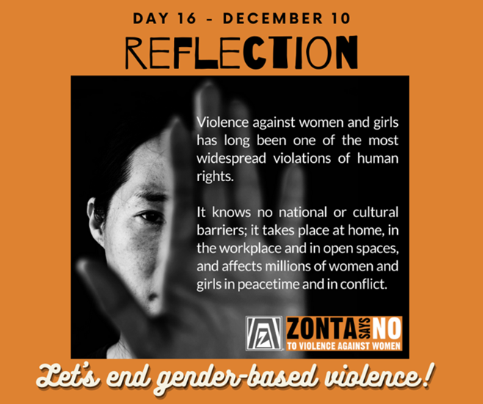
How will you make a difference? For Zontians there are so many opportunities to learn and get involved! For those who are not in Zonta, join us in our mission to make the world and our community a better place for women and girls! Advocate, communicate and/or donate your time, skills, dollars, or other resources. You can be part of the solution and truly make a difference!

ZontaSaysno.com
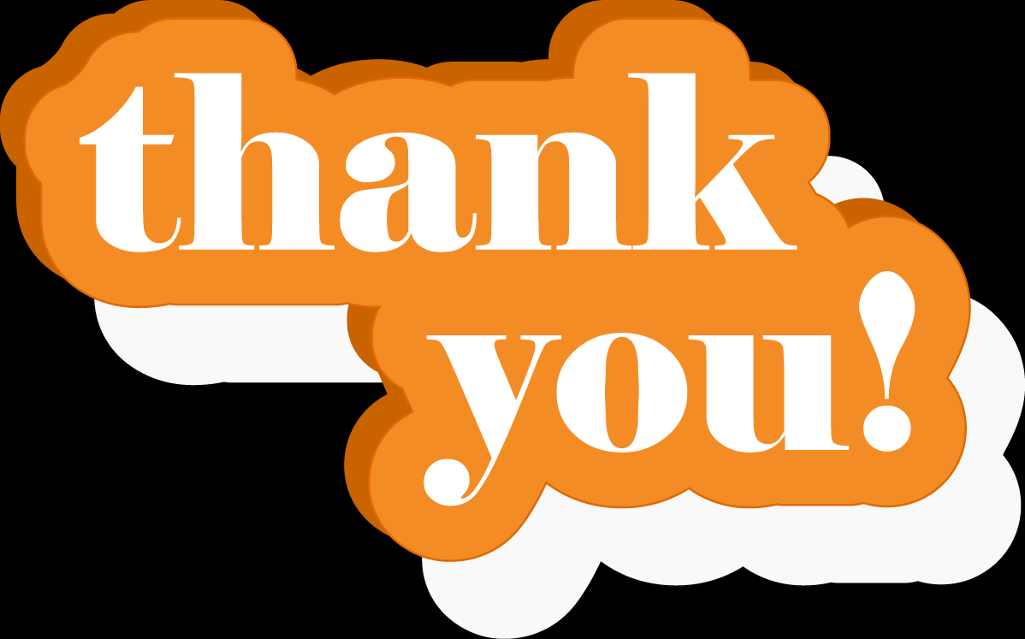

Thank you for participating in Zonta Club of Corvallis’ 2025 “Sixteen Days of Activism”
Lots of deserved recognition and appreciation for the many who helped to make the past “Sixteen Days” a success.
Special recognition to the Zontians and others who attended the “Light Up the Bridge” in Portland.
Special thanks also to 16 Days Official Photographer, Rebecca Yu; Webmaster, Diana Simpson-Godfrey; and , Social Media Manager, Helen Garber.
Congratulations to the members of the Corvallis Zonta Club’s Advocacy Committee for all of their hard work and support of “16 Days of Activism!” Committee members included Ruth Johns - Chair, Carol Trueba, Helen Garber, Carol Walsh, Victoria Condor-Williams, Pete Bober and “ex officio” member, President Mary!
Thanks to all for a successful campaign!

ZontaSaysno.com

