Sixteen Days of Activism!
Welcome to Zonta Club of Corvallis’ Day 16 of “Sixteen Days of Activism” for 2023.
Today is the last and final day of the Zonta Club of Corvallis’ Sixteen Days of Activism! During the past sixteen days we hope we have educated you, informed you and most importantly motivated you to act! There are so many ways you can help to end gender violence. Join Zonta in their mission to make the world and our community a better place for women and girls! Advocate, communicate and/or donate your time, skills, dollars, or other resources. You can be part of the solution and truly make a difference!
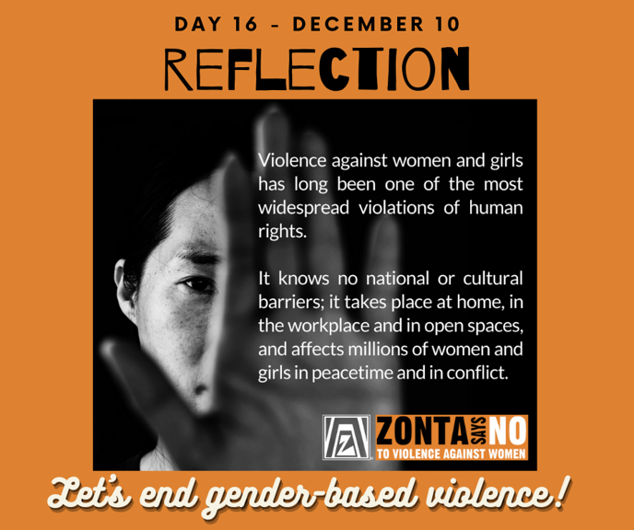

Learn more and get involved with #Zontasaysno to violence against women and supporting gender equity at ZontaSaysno.com

