Sixteen Days of Activism!
Welcome to Zonta Club of Corvallis’ Day Two of “Sixteen Days of Activism” for 2023.
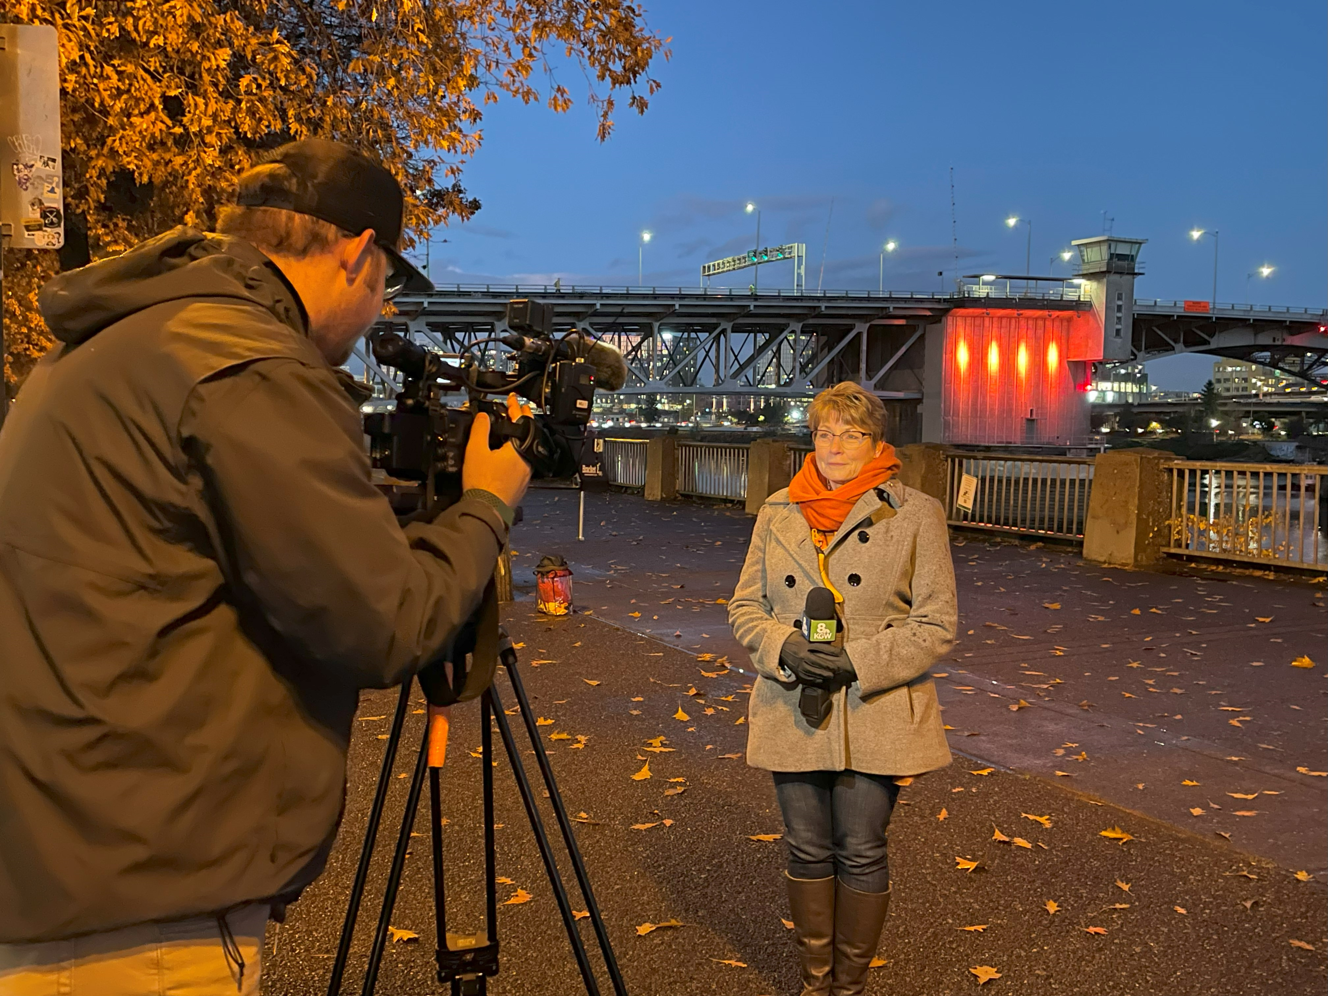
District Eight Governor Deb Lal at last year’s Morrison Bridge Lighting in Portland!

Check out Zonta District Eight’s website regarding the 16 Days of Activism Campaign!

Learn more and get involved with #Zontasaysno to violence against women and supporting gender equity at ZontaSaysno.com

